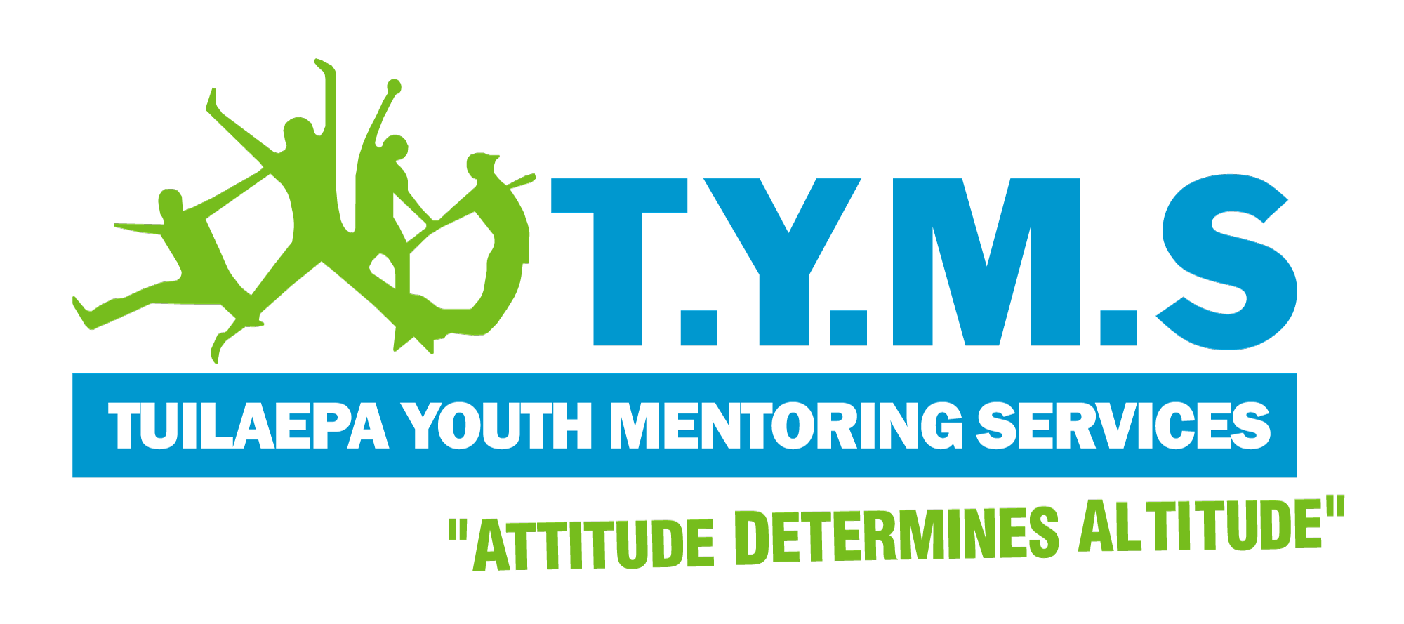
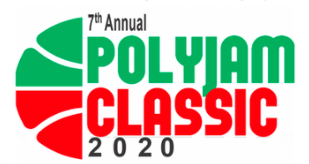
Polyjam Classic 2020
Full-day Pacific Basketball Competition

REGISTRATION FORM FOR INDIVIDUALS

Saturday 5th December 2020 | Birdwood Park, Ranui

Full Name: _______________________________________________ Age: _____

Mobile: ___________________________________________________ Singlet Size: _____

Email: ____________________________________________________

Ethnicity/Village/Iwi:___________________________________________________

Have you played Basketball before? _____________________________________
(If so, what team or league?)

Please Tick which league you are registering for

☐ Open Adults League ☐ Under 14’s Comp (FREE)

Preference of Team (Fiji, Tonga, Niue, Cook Islands, Samoa West-Auckland, Samoa South-Auckland, Samoa Central, Philippines or All Nations)

1st Choice ________________________________

2nd Choice ________________________________

☐ I acknowledge that this is a smoke-free and alcohol-free event.

You will be notified of your assigned team ASAP by text or email. Once you’ve been assigned a team, please contact your Team manager or for a TYMS representative, you can contact Langi at langi@tyms.org.nz for any questions or issues regarding the day.

Aside from the ‘Adults League’ player fundraiser fee ($25 per player or $250 per team)
we kindly ask for each player to bring along canned items of non-perishable food, and a toy which gets placed in our Christmas hampers for families and children in need

Signature: Date:

