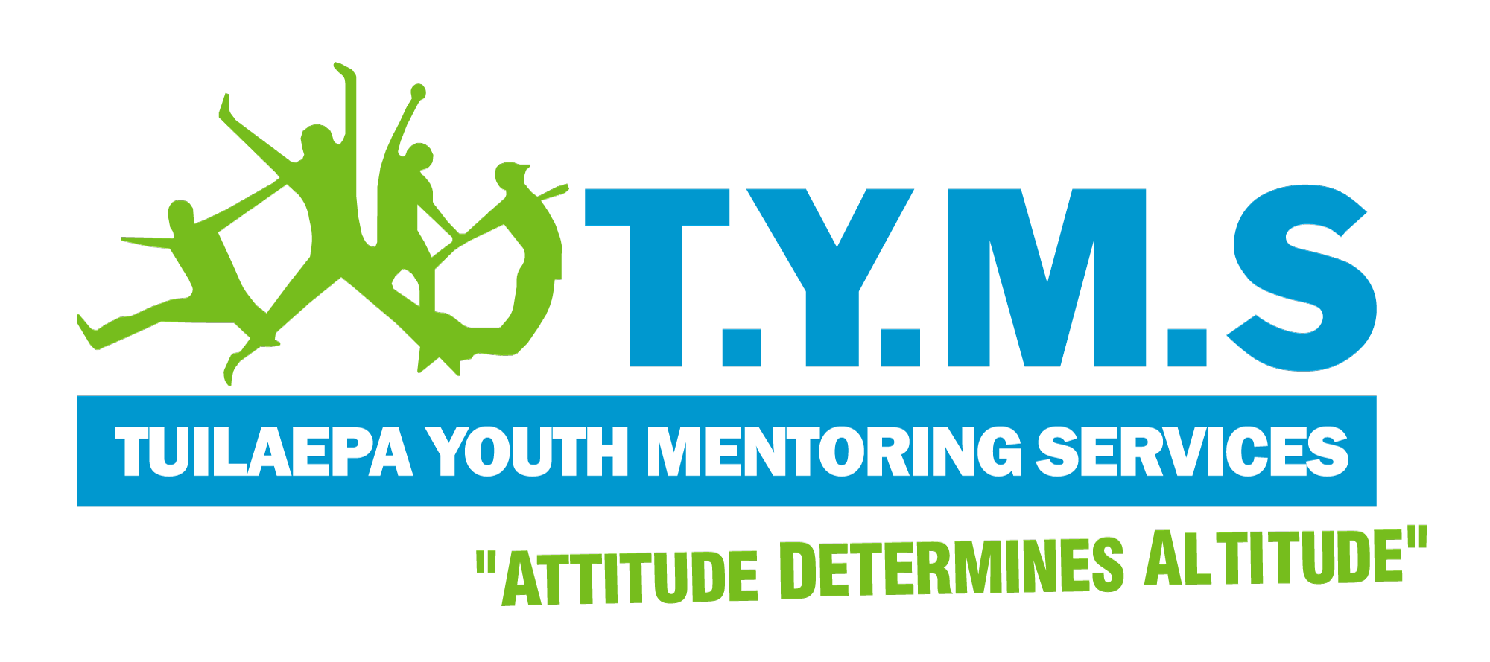
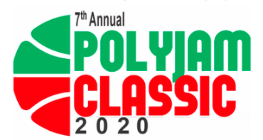
Polyjam Classic 2020
Full-day Pacific Basketball Competition

Saturday 5th December 2020 | Birdwood Park, Ranui

REGISTRATION FORM (FOR TEAMS)

Team Name (Country):

No. players | First and Last Name (Singlet Size) | Mobile | Village/Iwi
1
2
3
4
5
6
7
8
9
10
Extra

Team Captain Name:

Manager Name: Manager Mobile:
I acknowledge that I am responsible for the actions and behaviour of my team, and that I will take care and be accountable for the return of all TYMS singlets at the end of the tournament.

Signature: Date:

